PROMISE & PRACTICE · DEEP DIVE · SOURCE ANALYSIS
Black Codes & Sharecropping — A House Divided
Free on Paper, Bound in Practice
Name: ______________________________ Period: _____ Date: ________________
WHAT I CAN DO TODAY I can read primary sources about Black Codes & Sharecropping — A House Divided, weigh who made each one and why, and use evidence to answer historical questions.
Directions. Some things changed; some things stayed the same. Sorting which is the heart of this skill

THE SOURCES
THE IMAGE · 1862 — A freedpeople family, 1862
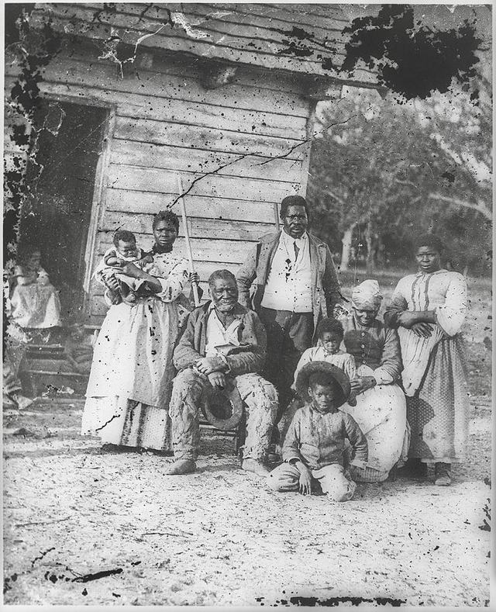
A family born into slavery on Smith’s Plantation, Beaufort, South Carolina — photograph by Timothy H. O’Sullivan, 1862, public domain (Library of Congress).
SOURCE · HOW SHARECROPPING WORKED — The debt cycle
A sharecropper farmed a landowner's land for a share of the crop. He borrowed — at high interest — for seed, tools, and food against the coming harvest. At settlement, the landowner's accounts often showed the cropper still owed money. The law then required him to keep working to pay the debt. The next year began the same way.
— summarized from the historical record. Public domain
— summarized from the historical record. Public domain.

YOUR WORK
QUESTION 1 STEP 1 · THE BLACK CODES
Give two specific examples of how the Black Codes restricted the freedom of formerly enslaved people.
____________________________________________________________________________________________
____________________________________________________________________________________________
____________________________________________________________________________________________
QUESTION 2 STEP 2 · THE TRAP
Why did sharecropping so often trap families in poverty, year after year?
☐ A. they had to borrow at high interest and the debt rarely got paid off
☐ B. they refused to work
☐ C. crops always failed
☐ D. they owned too much land
QUESTION 3 STEP 3 · CHANGE VS. CONTINUITY
Compared with slavery, name one real thing that changed for freedpeople, and one important thing that stayed the same.
____________________________________________________________________________________________
____________________________________________________________________________________________
____________________________________________________________________________________________
QUESTION 4 STEP 4 · HOW FREE?
This 1862 photograph shows a family in the first days of freedom. In three or four sentences, use the evidence to explain how the Black Codes threatened the freedom these people had just won — how much had really changed?
____________________________________________________________________________________________
____________________________________________________________________________________________
____________________________________________________________________________________________
____________________________________________________________________________________________
____________________________________________________________________________________________
Promise & Practice · ShadowDog Digital Studios · Unit 2

TEACHER ANSWER KEY — Black Codes & Sharecropping — A House Divided

QUESTION 1: Open response.
Look for a response along the lines of: “1)… 2)…”
QUESTION 2: Correct — A. they had to borrow at high interest and the debt rarely got paid off
Right. Croppers had to borrow at high interest against the crop, and the landowner kept the accounts — so they often ended up owing more than they earned and were legally bound to keep working.
QUESTION 3: Open response.
Look for a response along the lines of: “Changed:… | Stayed the same:…”
QUESTION 4: Open response.
Look for a response along the lines of: “Slavery was legally dead, but…”

